

**YEAR: 7**

**SUBJECT: SCIENCE**

**TEST: Moon and Tides**

**TIME: 50 minutes**

**QUESTIONS: Part A: Multiple Choice Questions (12 marks)**

**Part B: Short Answer Questions (27 marks)**

**TOTAL MARKS: 39 marks**

**SECTION ONE: Multiple Choice Questions (1 mark each)**

**Answer this section on the separate multiple choice answer sheet**

1. What force keeps the planets (including Earth) orbiting the Sun?

1. Air pressure
2. The Sun’s gravity
3. Buoyancy
4. The angle of the Earth on its axis

2. What is gravity?

1. It lets us float because every object is made up of matter
2. The non-contact force that pulls objects to the centre of the Earth
3. The contact force that pushes objects to the centre of the Earth
4. Is an example ofa frictional force because it attracts objects to the centre of the Earth

3. What two forces act on all falling objects in the Earth’s atmosphere?

1. Buoyancy and gravity
2. Gravity and surface tension
3. Gravity and air resistance
4. Buoyancy and air resistance

4. What is the weight on Earth of a person with a mass of 60 kilograms?

1. 60 kg
2. 600 N
3. 60 km
4. 500 m3

5. Mars rover was built on Earth and has been sent to Mars to send back information about the terrain. The Mars Rover has a mass of 185kg. The gravitational pull on Mars is 3.711 m/s2, Earth has a gravitational pull of 9.8m/s2. Select the statement which is most correct.

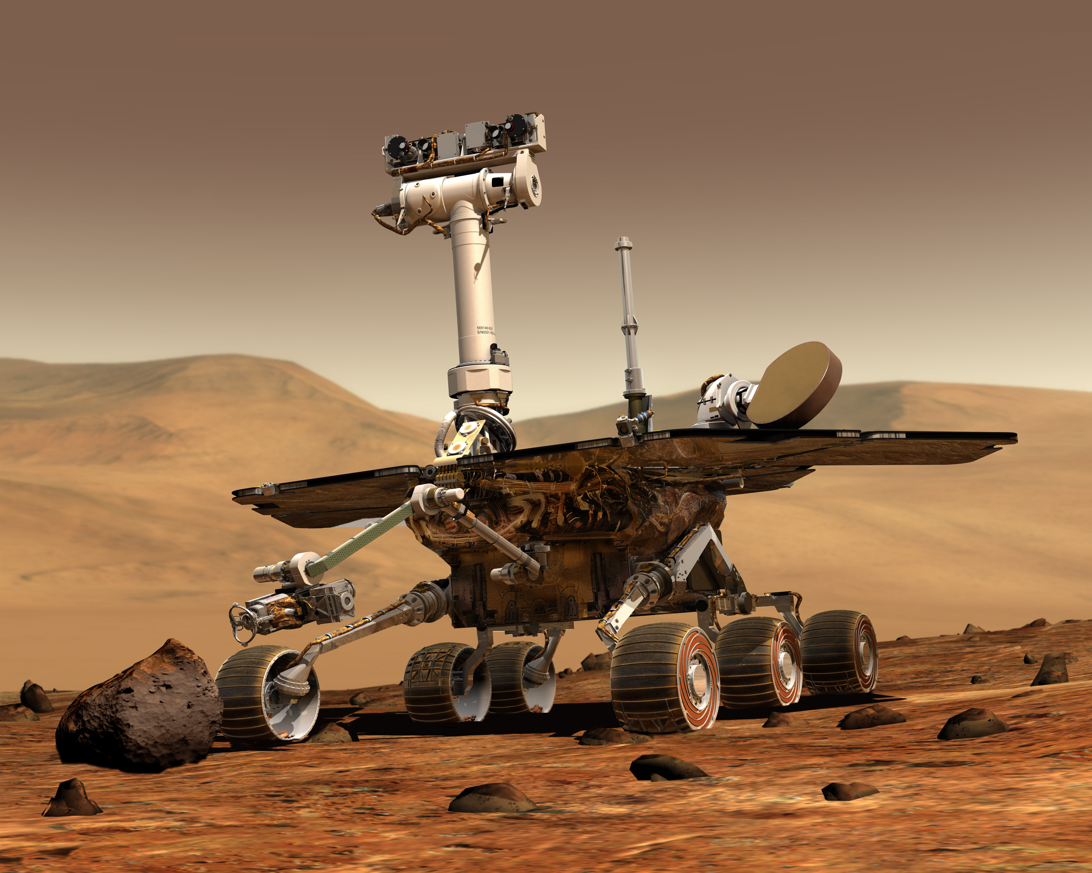

[This Photo](http://tr.wikipedia.org/wiki/Dosya:NASA_Mars_Rover.jpg) by Unknown Author is licensed under [CC BY-SA](https://creativecommons.org/licenses/by-sa/3.0/)

1. The Mars rover will have a heavier weight on Mars.
2. The Mars rover will be lighter weight on Mars.
3. The weight of the Mars rover will remain constant.
4. There is not enough information to determine if the weight will be affected.

6. What makes objects have different gravitational forces?

1. Mass
2. Weight
3. Friction
4. Magnetism

7. What causes tidal movements?

1. The gravity of the water in the ocean is constantly changing
2. The Moon’s gravitational pull causes oceans to move away from it
3. The Moon’s gravitational pull causes oceans to bulge out towards it
4. The Earth’s gravitational pull causes oceans to bulge out towards the Moon

8. The different shapes of the Moon as seen from Earth are called

1. Crescents
2. Phases
3. Quarters
4. Fractions

9. The main cause of day and night is:

1. Rotation of the Earth
2. Revolution of the Earth
3. Orbit of the Earth
4. The tilt of the Earth on its axis

10. Which of the following is not a Noongar Season.

1. Birak
2. Djeran
3. Makuru
4. Kaya

11. Select from the options below the most accurate definition for equinox

1. The middle of summer
2. The middle of winter
3. Day on which night and say last for an equal amount
4. Day where the most sunlight is experienced

12. Which of the following diagrams best shows the relative positions of Earth, the Moon

and the Sun during a lunar eclipse?



**SEMESTER ONE 2021**

**Moon and Tides:**

**ANSWER BOOKLET**

**NAME:**

**FORM:** **DATE:**

Multiple Choice Short Answer Total

**/39**

**/35**

**/27**

**/12**

**/12**

**SECTION ONE:** Multiple choice answers

Cross (X) through the correct answer.

|  |  |  |  |  |
| --- | --- | --- | --- | --- |
| 1 | a | b | c | d |
| 2 | a | b | c | d |
| 3 | a | b | c | d |
| 4 | a | b | c | d |
| 5 | a | b | c | d |
| 6 | a | b | c | d |
| 7 | a | b | c | d |
| 8 | a | b | c | d |
| 9 | a | b | c | d |
| 10 | a | b | c | d |
| 11 | a | b | c | d |
| 12 | a | b | c | d |

|  |  |
| --- | --- |
| **I CAN STATEMENT** | **QUESTIONS** |
| **MUST**  Describes how the positions of the Earth, sun and moon affect phenomena on Earth. | 1, 2, 5, 7, 8, 9, 10, 11, 13, 14, 17a, 18, 19 |
| **SHOULD**  Explains how the positions of the Earth, sun and moon affect phenomena on Earth. | 3, 6, 12, 15a, 15b, 17b |
| **COULD**  Explains how the positions of the Earth, sun and moon can be used to predict phenomena on Earth. | 4. 15c, 16 |

**SECTION TWO: Short Answer (27 marks)**

Answer the questions in the spaces provided.

**Question 13**

Use the terms from the following list to complete the sentences below. (4 marks)

*half Earth Sun sunlight far between differently reflects*

The Moon doesn’t create its own light. We only see the Moon from Earth because the Moon ____________________ light from the __________________. One _________________ of the Moon is always illuminated. A full Moon occurs when the Moon is on the _________________ side of the _______________ and the full light of the Sun reflects to Earth. A new Moon occurs when the Moon is ____________________ the Sun and the Earth, we can’t see any of the ___________________ that is hitting the Moon. The Northern and Southern Hemispheres see the Moon’s phases __________________.

**Question 14**

Write the definition of the following words: (3 marks)

Winter solstice

______________________________________________________________________________________________________________________________________________________

Solar eclipse

______________________________________________________________________________________________________________________________________________________

Seasons

______________________________________________________________________________________________________________________________________________________

**Question 15**

1. Sketch the shape of (3 marks)

(i) A waxing crescent moon

1. A waning gibbous moon
2. A full moon
3. Explain why we see various moon shapes or phases? (2 marks)

____________________________________________________________________________________________________________________________________________________________________________________________________________________________________________________________________________________________________________

1. Explain how the Northern and Southern Hemispheres see the Moon’s phases differently.

(2 marks)

____________________________________________________________________________________________________________________________________________________________________________________________________________________________________________________________________________________________________________

**Question 16**

Explain how the Moon is responsible for producing tidal movements in Earth’s oceans.

(3 marks)

________________________________________________________________________________________________________________________________________________________________________________________________________________________________________________________________________________________________________________________________________________________________________________________________________________________________________________________________________________________________________________________________________________________________________________________________________________________

**Question 17**

1. Describe why a person would weigh more on Earth than on Moon. (2 marks)

_________________________________________________________________________________________________________________________________________________________________________________________________________________________________

1. The apple has a mass of 200 grams (0.20 kg). Using the formula for weight calculate the weight of the apple on Earth and the moon. **(Hint: make sure to include the correct units for weight in your answer)**  (2 marks)

Weight = mass x gravitational pull

= m x g

|  |  |  |  |
| --- | --- | --- | --- |
| Celestial Object | Mass (kg) | Gravitational Pull  (m/s2) | Weight |
| Moon | 0.20 | 1.62 |  |
| Earth | 0.20 | 9.8 |  |

**Question 18**

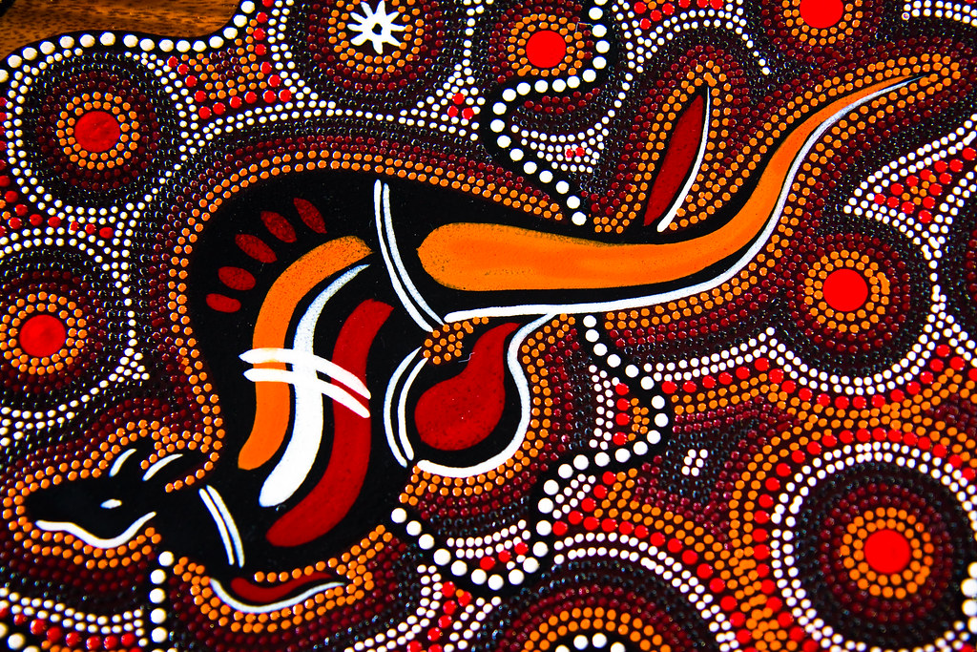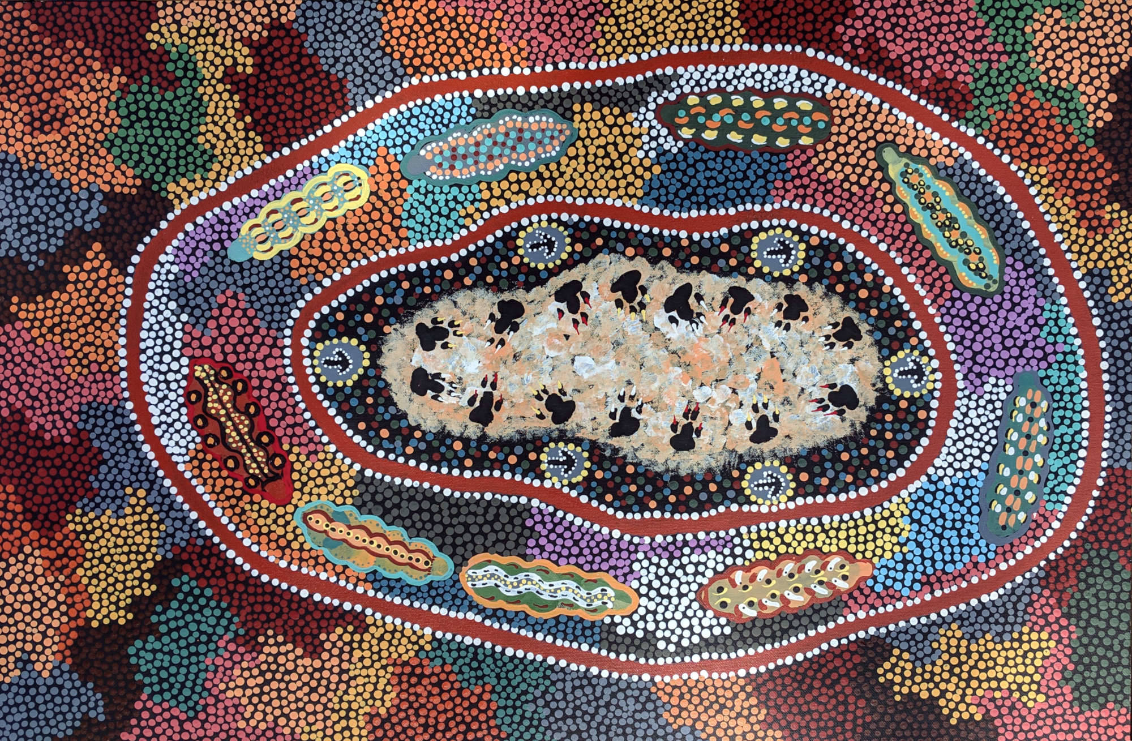State how Aboriginal peoples’ verbal traditions successfully communicate knowledge across generations. Use an example to support your statement. (2 marks) _______________________________________________________________________________________________________________________________________________________________________________________________________________________________________________________________________________________________________________________________________________________________________________________

**Question 19**

1. On the diagram below, correctly label the four seasons for the Southern Hemisphere.

(4 marks)

1. Do the Southern Hemisphere and Northern Hemisphere experience the same season at the same time? (1 mark)

|  |
| --- |
|  |

**END OF TEST**

Please go back and check your work / complete any unanswered questions.